If you get numpy error :
Steps to follow :
- Inside your project folder install numpy
python -m pip install numpy
- Then check the python folder location where it’s update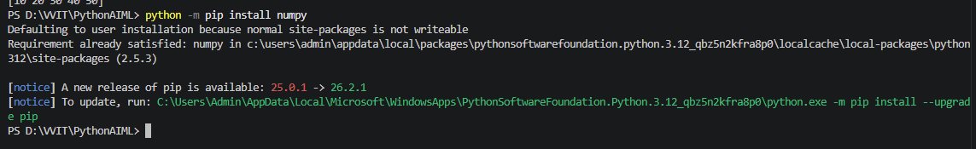
- Open the Command Palette with Ctrl+Shift+P, choose Python: Select Interpreter, and select the environment you use for this project. 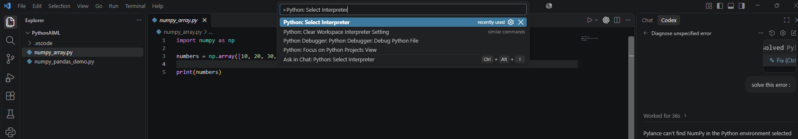
- If Pylance still shows the warning, choose Developer: Reload Window from the Command Palette. 